FRONT-END PROGRAMMING CSM3103



UNIVERSITI MALAYSIA TERENGGANU

LAB MODULE 3

NAME : ILHAM HANINA MADIHA BINTI OTHMAN

MATRIC NO : S63762

PROGRAMME: BACHELOR OF COMPUTER SCIENCE (MOBILE COMPUTING)

LECTURER : DR RABIEI B MAMAT

GITHUB LINK : <https://github.com/ilhamhanina/Code-Lab-CSM3103-S63762.git>

Task 1 – JavaScript Function

1. Write a function to find the square of a given number

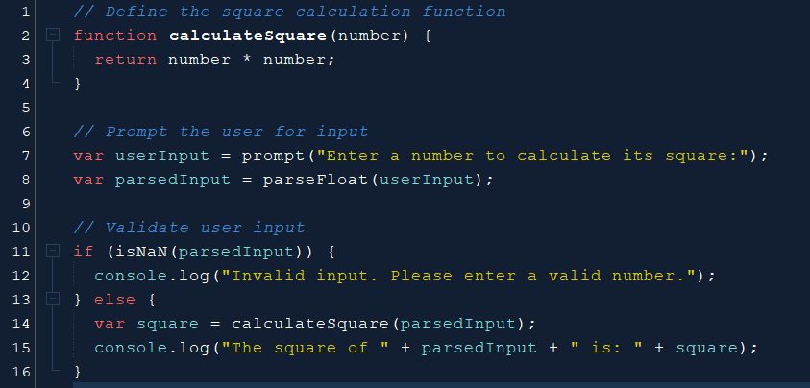

2. Write a function to find sum of cubes of two numbers

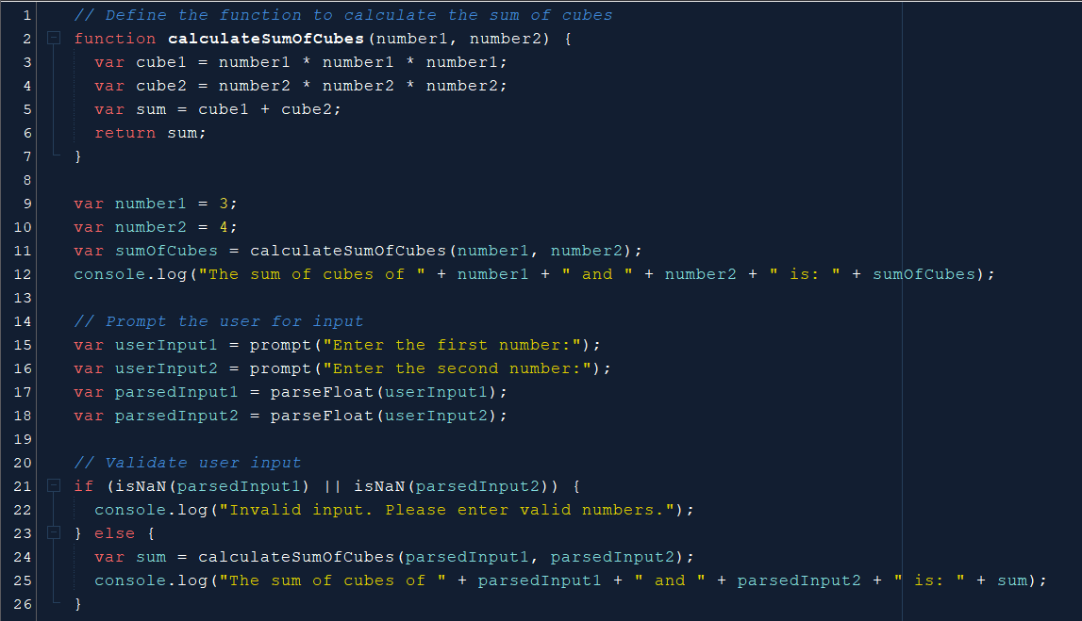

3. Write a function to reverse a number  
[Hint n = 12345 output : 54321 ]

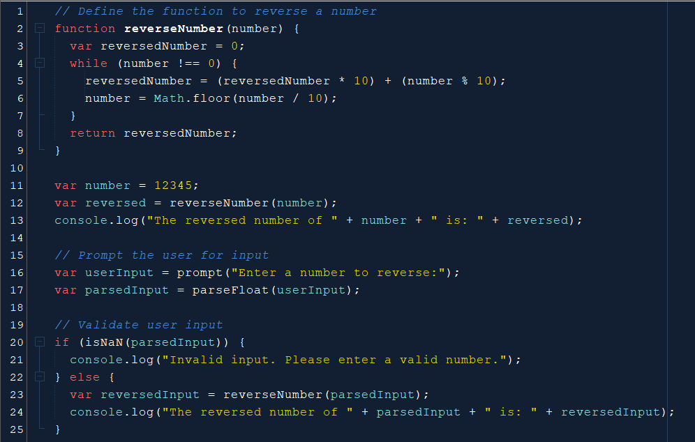

4. Write a function to print all numbers between 1 and 100 which is divisible by given number z

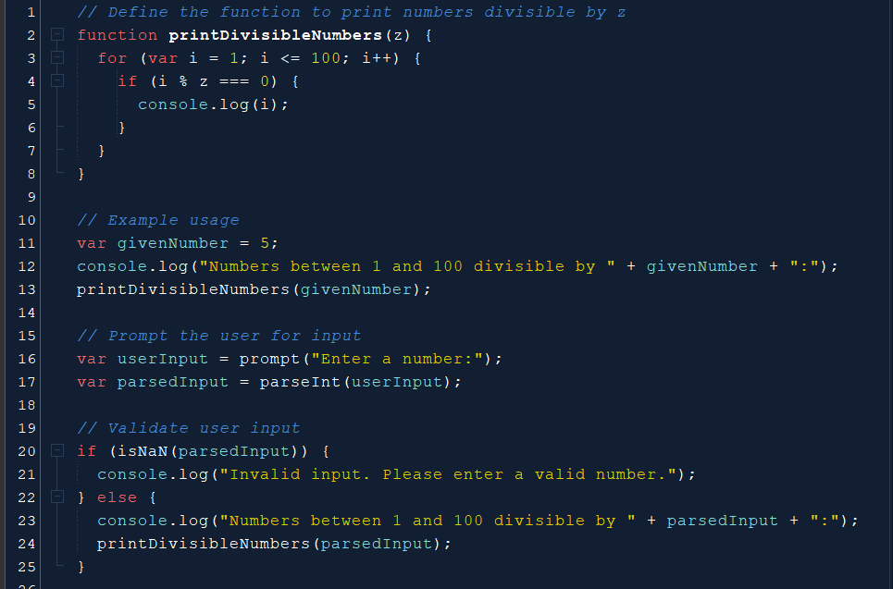

Task 2 – JavaScript Recursion Function

1. Write a JavaScript function to find sum of digits of a number

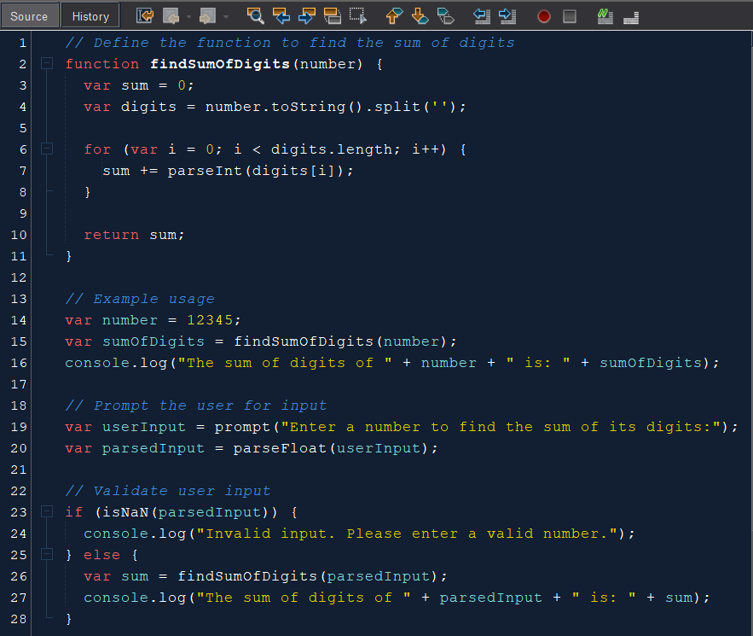

2. Write a JavaScript program to compute x raise to the power y using recursion

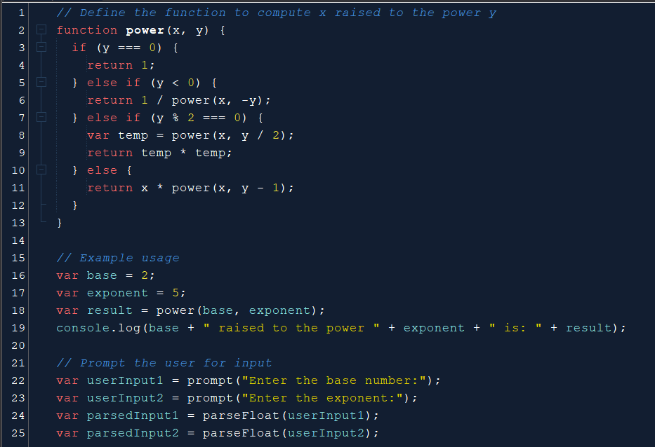

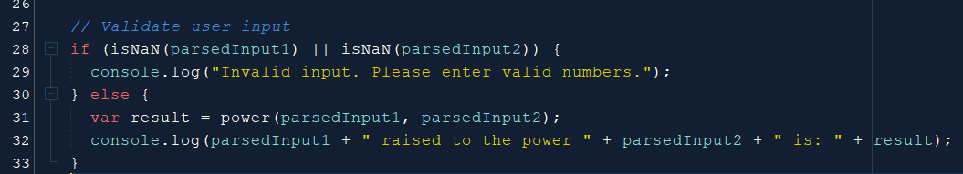

Task 3 – JavaScript Object and Prototype

1. Write a JavaScript program to create object product,

a. Add the property Product Name, Quantity and price.

b. Access all the properties and display them.

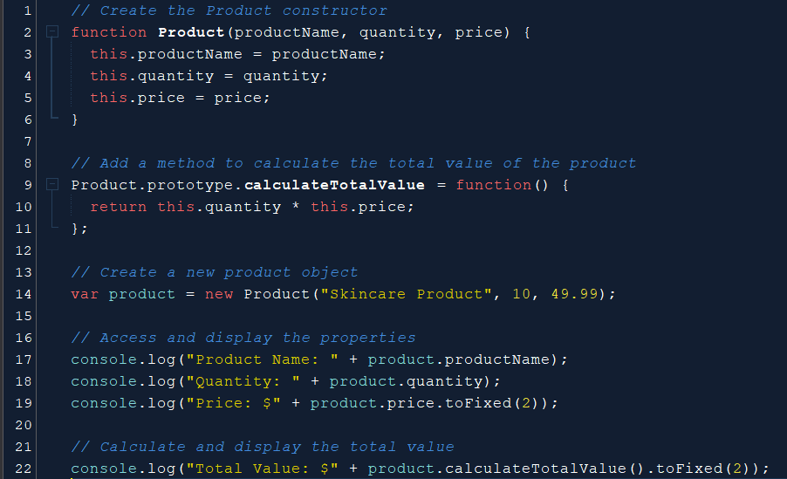

2. Write a JavaScript program to create object book

a. Add the property book name, author name

b. Add the prototype property price

c. Display all the properties.

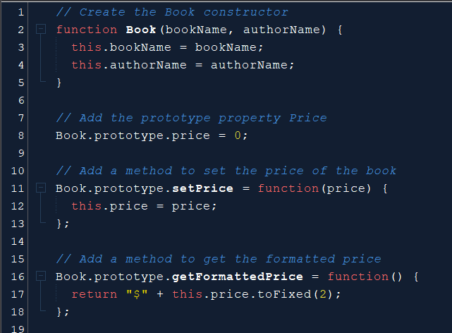

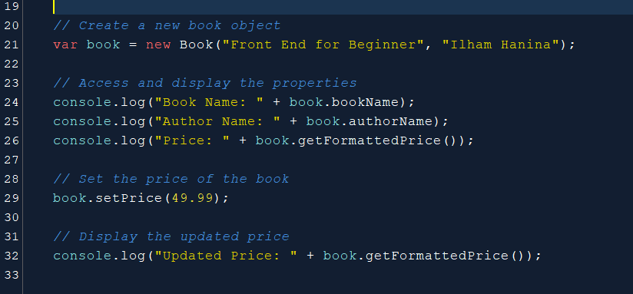

3. Write a JavaScript program to create Parent object employee (Property : Employee Name , Employee Id , Salary) and Child object Manager (Property : Manager Name , Branch). Inherit all the properties of employee and display all the properties.

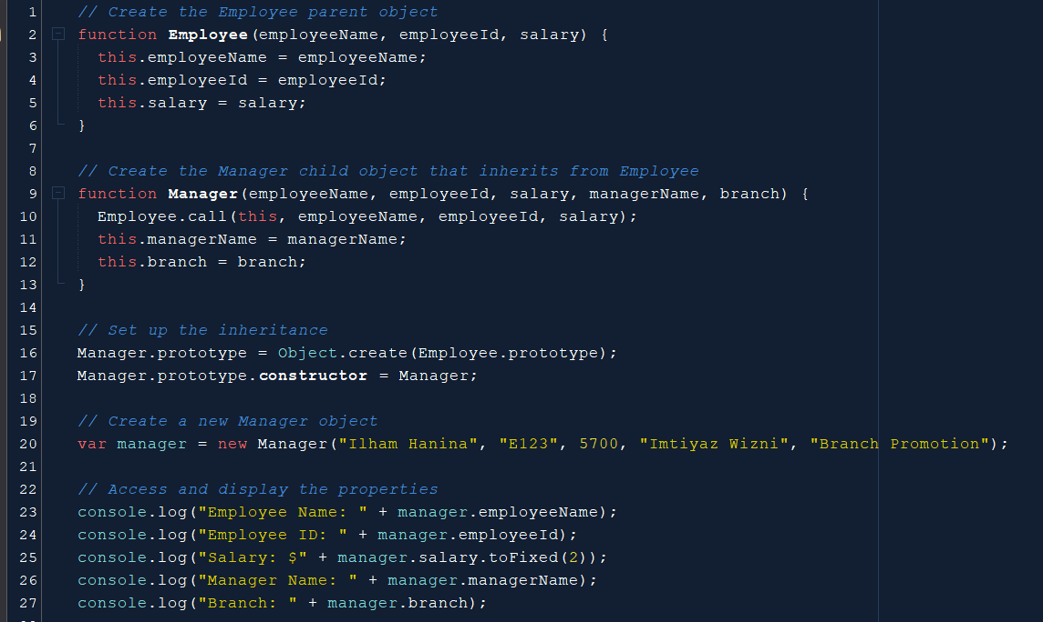

Task 4 – Event Manager

1. Create a HTML page with <p> paragraph. Change the paragraph color according to the following mouse events.

a. Onclick, yellow background

b. ondblclick, blue background

c. onmouseover , red background

d. onmouseout, green background

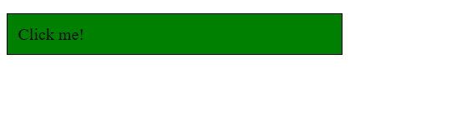

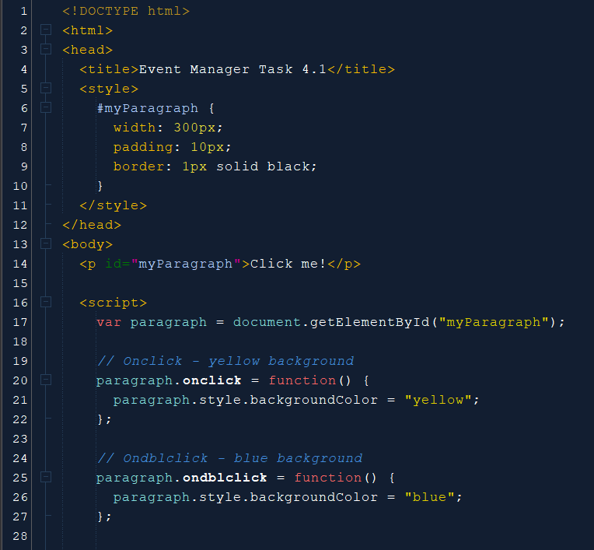

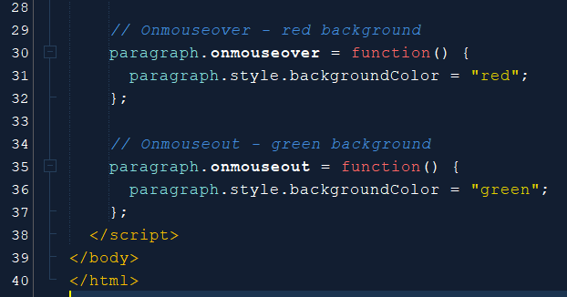

2. Create a HTML page with textfield. Show some effects on the textfield when the following events occurred:

a. Onchange

b. Onfocus

c. onblur

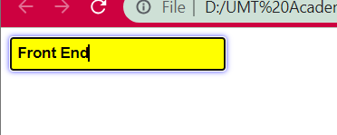

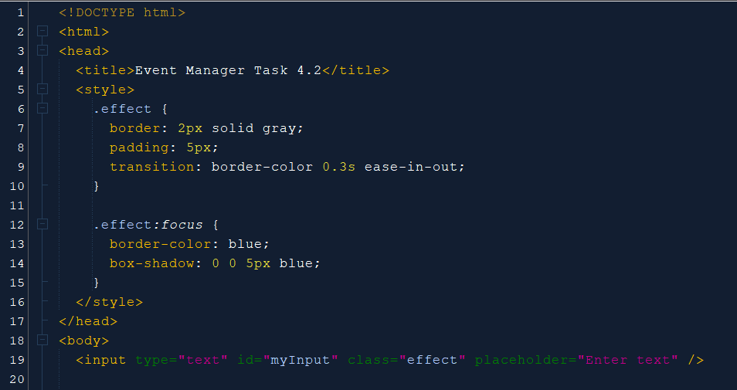

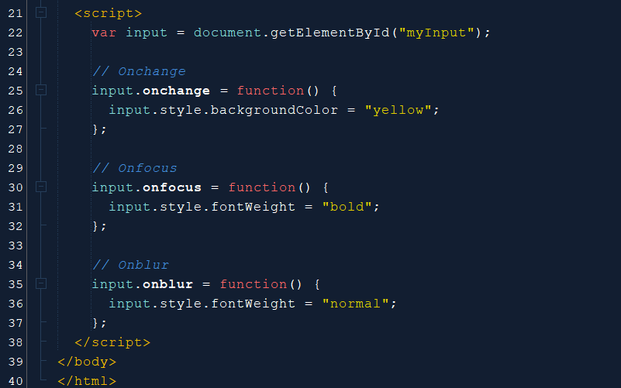

Task 5

Given the following HTML table

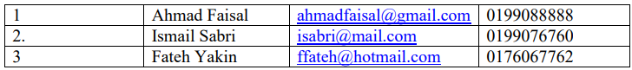

1. Using javascript add the following record into table

a. Name: Mukhriz Jamil Asoka

b. Email: [mukriz@corp.jo](mailto:mukriz@corp.jo)

c. Phone: 651181187223

2. Using javascript add the table header as follow:

a. #, Name, Email, Phone #

3. Using javascript, delete any row from table when clicked on that row

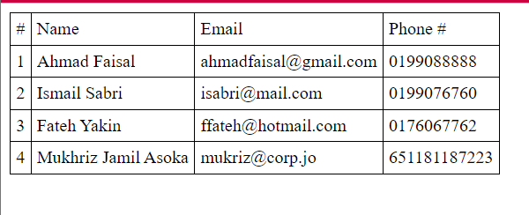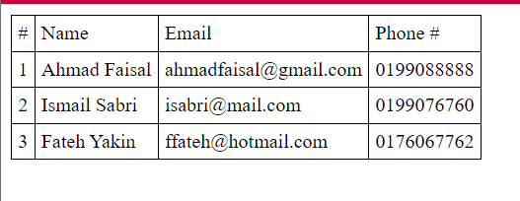

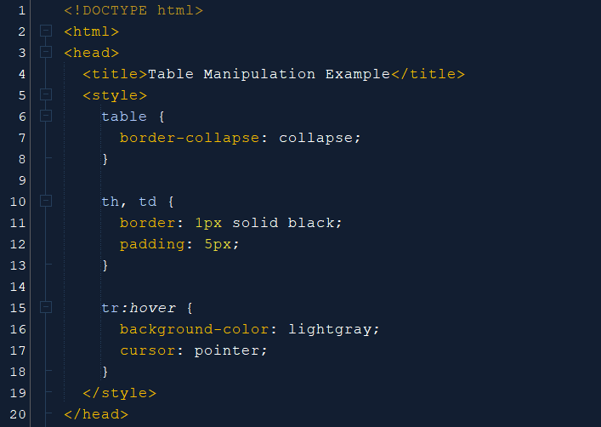

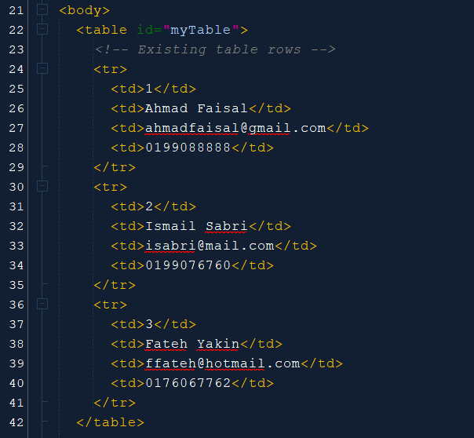

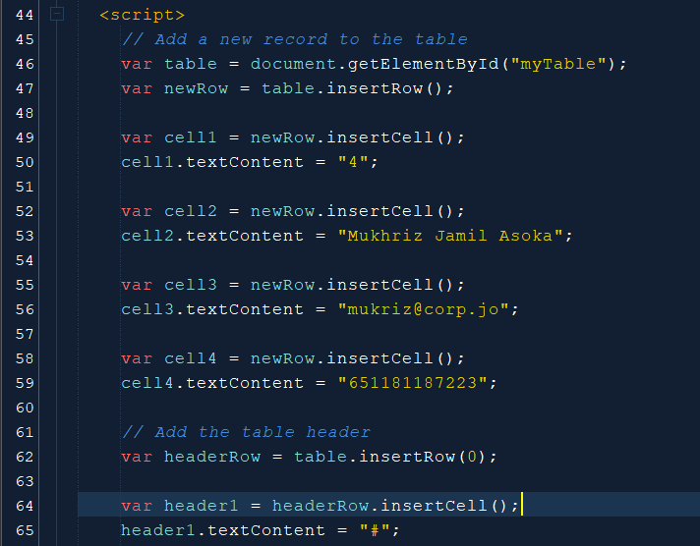

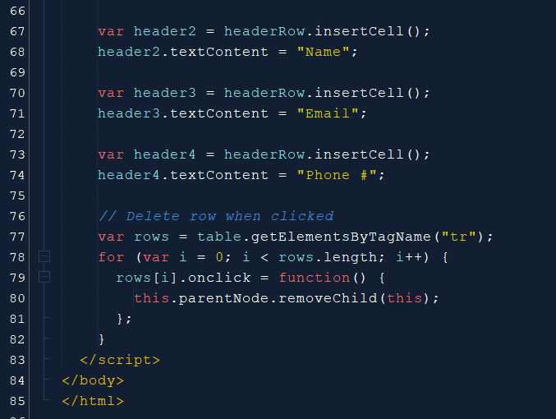

Task 6

Write a JavaScript program to move two small squares inside one big square in a random manner. User should be able to start and stop this animationusing button based events

**Math.floor(Math.random() * Math.floor(max)) will give you a random number that is less than max value**

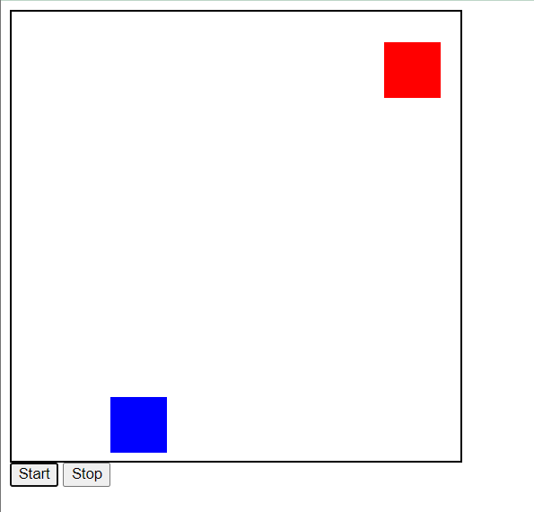

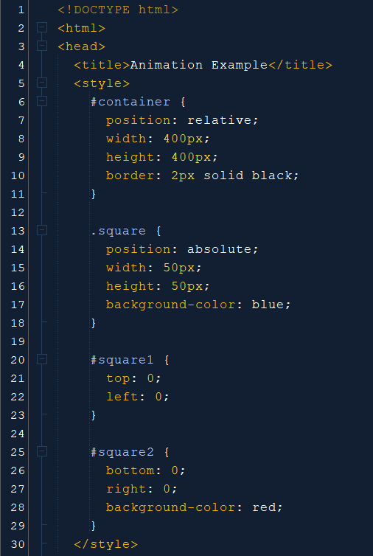

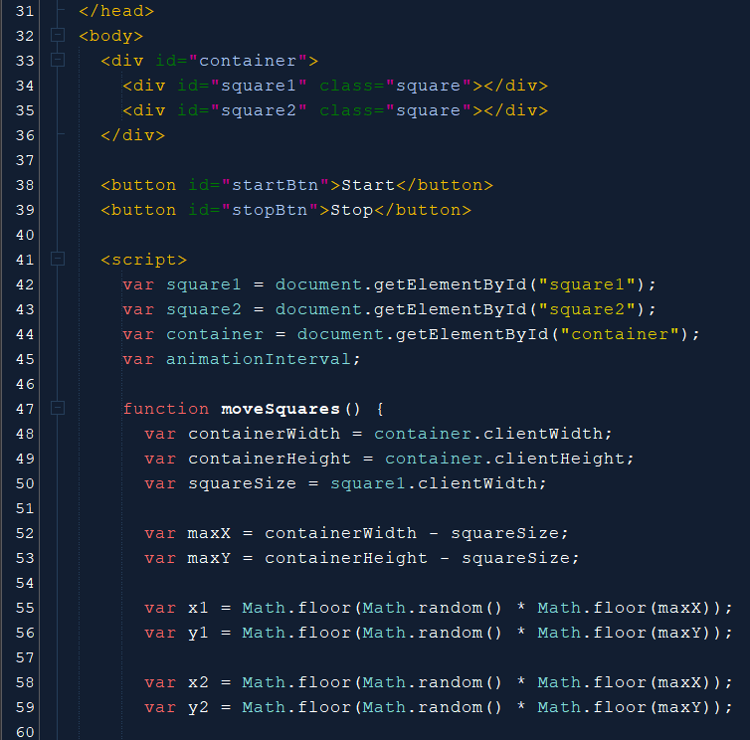

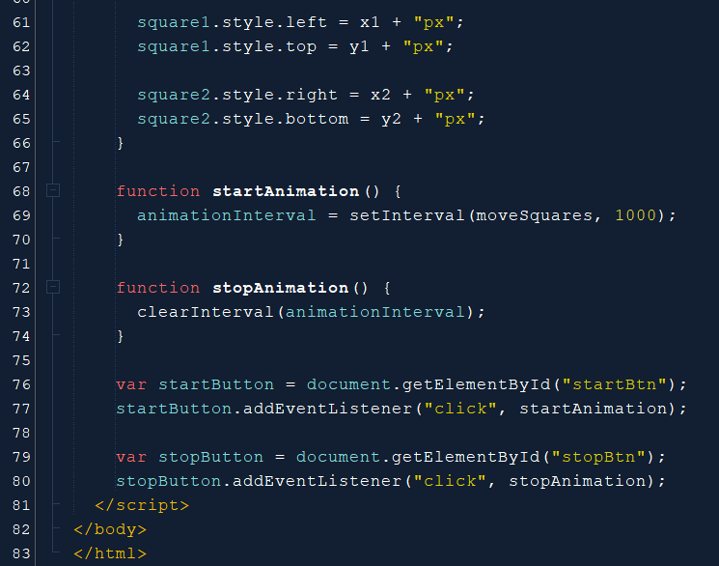

Link GitHub for the lab : <https://github.com/ilhamhanina/Code-Lab-CSM3103-S63762.git>